# BMI (Body Mass Index)

**Introduction:**

The body mass index (BMI) is a measure that uses your height and weight to work out if your weight is healthy.

**Idea:**

Creating a Body Mass Index (BMI) calculator is a straightforward but useful project. BMI is a commonly used metric to assess an individual's body weight in relation to their height.

**Explanation:**

BMI serves as a quick and widely used screening tool to assess whether an individual has a healthy body weight. However, it has limitations. It does not directly measure body fat or account for muscle mass, making it essential to interpret BMI results in conjunction with other health assessments.

**Importance:**

* Health Screening:

BMI is crucial for quick health screenings, helping to identify individuals who may be at risk of health problems associated with being underweight or overweight.

* Population Health Studies:

It facilitates population-level health studies, enabling researchers and healthcare professionals to assess trends in body weight distribution and associated health risks within communities.

* Health Interventions:

BMI is often used to guide health interventions and public health policies, aiming to address issues related to obesity, malnutrition, and related health conditions.

* Clinical Assessments:

In clinical settings, BMI is a starting point for discussions about an individual's weight and can guide further assessments and interventions tailored to the patient's specific health needs.

* Monitoring Changes:

It provides a baseline for monitoring changes in body weight over time, assisting both individuals and healthcare providers in tracking progress in weight management programs.

**Calculation:**

It is calculated by dividing a person's weight in kilograms by the square of their height in meters, using the formula BMI:

Or, If Using Pounds and inches:

After calculating BMI, the resulting numerical value is used to categorize an individual into different weight status categories. These categories help provide a general indication of the person's body fatness and potential health risks associated with their weight. The common BMI categories are:

**Implementation:**

* **Underweight**:

If Your BMI is less than 18.5 than our BMI calculator will show this MENU:



We Will Discuss 2 Main Topics in this Report. These Are:

**Causes:**

These are further explained in detail.

**Treatments:**

These are further explained in detail.

* **Healthy:**

- If a person BMI is between 18.5 and 24.9 our BMI calculator will show this MENU:

We Will Discuss 2 Main Topics in this Report. These Are:

**Exercises:**

These are further explained in detail.

**Diet:**

These are further explained in detail.

* **Overweight:**

- If a person BMI is between 25 and 29.9 our BMI calculator will show this MENU:

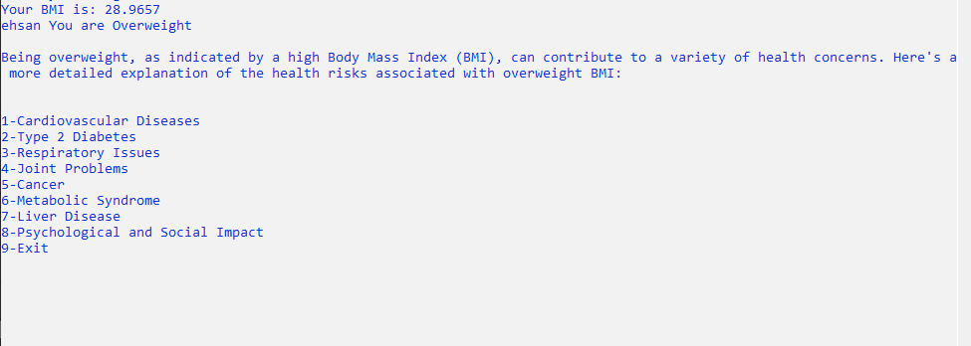

These are further explained in detail.

Let’s view 1st Heading:



Again, exploring the 1st Heading:



So, as you see our calculator explain everything in detail.

* **Obesity:**

- If a person BMI is greater than 30 our BMI calculator will show this MENU:

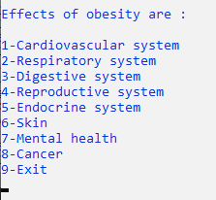

In 1st Heading:

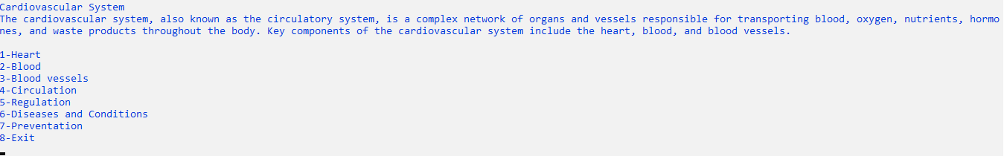

Again, Exploring the 1st:



These categories serve as a starting point for discussions about an individual's weight and potential health risks. However, it's important to note that BMI has limitations and does not directly measure body fat or consider muscle mass. Therefore, additional health assessments may be needed for a more comprehensive understanding of an individual's health status.

**Conclusion:**

In conclusion, the BMI calculator can be a useful initial assessment tool for identifying potential weight-related health risks at the population level. However, it does not account for variations in muscle mass, distribution of fat, and other factors that contribute to an individual's overall health. Therefore, it is recommended to use BMI in conjunction with other health assessments and measurements to obtain a more comprehensive understanding of an individual's health status. Additionally, consulting with healthcare professionals for personalized advice and a thorough assessment is crucial for making informed decisions about one's health and well-being.

**Outcomes:**

1. **Understanding Weight Category:** The BMI calculator helps sort people into different groups based on weight, telling if someone is underweight, normal weight, overweight, or obese.
2. **Assessing Health Risks:** If the BMI is high, especially in overweight or obese categories, there's a higher chance of health issues like heart disease and diabetes. People with a high BMI might need to make lifestyle changes for better health.
3. **Initial Health Check at the Doctor's:** Doctors often use BMI as a simple tool to see if someone might need extra checks. If the BMI shows overweight or obesity, the doctor might suggest more tests and talk about ways to be healthier.
4. **Analyzing Population Health Trends:** Researchers and health experts use BMI to see how many people in a group are underweight, normal, or overweight. It helps understand health trends in different communities.